Represent Functions
Equation: y = mx + b y looks like f(x)
f(x) = mx + y f(x)= output x= input f(x) is asking for the answer after inputting x.

Graph: 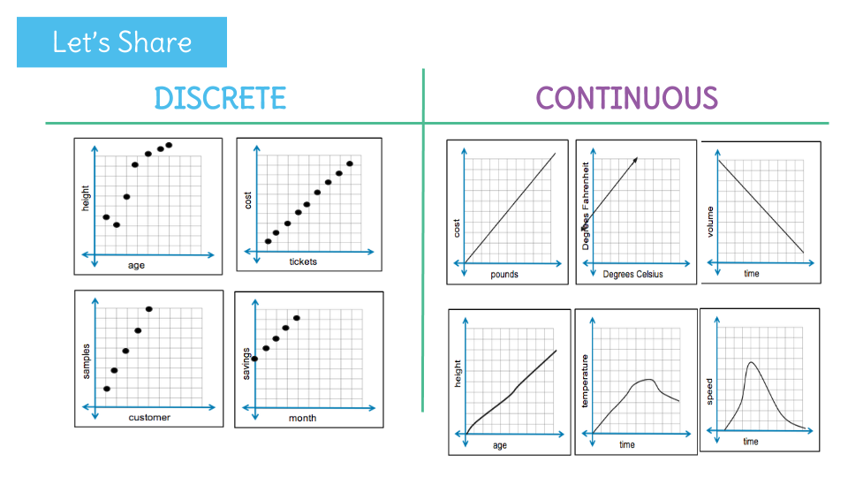
Table:
x | f(x)

Mapping Diagram:
2
4
6
8
1
2
3
4
1
2
3
4
6
6
1
2
3
4
Vertical Line Text
- X coordinates can’t overlap ; x can only have 1 distinct y

