Operations with Radicals (+, -, x)

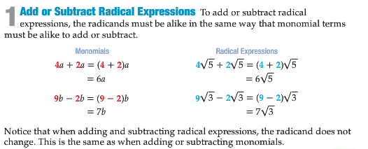

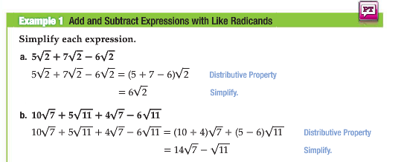

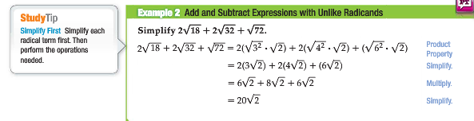

**Adding & Subtracting** radicals is extremely similar to adding & subtracting variables. You may only combine the coefficients of the like radicals (radicand & root), just as you would with like variables (letter(s) & exponent).

Unlike radicals must be simplified (take out the perfect square factor) to determine if a likeness of radicands exist.

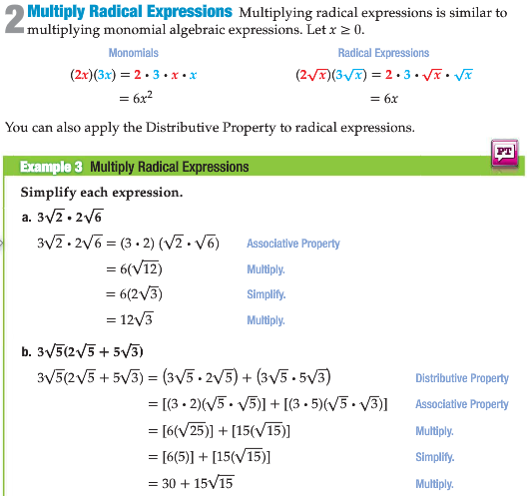

**Sometimes you have to apply the Distributive Property (FOIL)**

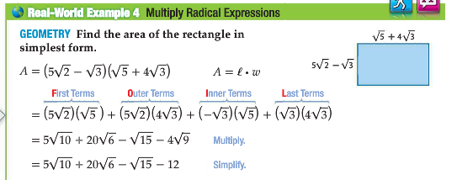

**Multiplying** radicals requires the radicands to be multiplied together under the radical. You should simplify the product.

Remember to expand what is being squared/cubed/etc. before applying the distributive property. Ex: 2 =  **not** 2

In Summary: